|  |  |  |  |  |
| --- | --- | --- | --- | --- |
|  |  | | |  |
|  | | |
|  | | |
|
|  | **XFUSION SCCM For FusionDirector Plug-in**  **v1.2.0**  **User Guide** | |  |  |
|  | |
| **Date** | **2022-04-20** |
| Copyright © Copyright Holder. All rights reserved. | |

|  |
| --- |
| Notice  The information in this document is subject to change without notice. Every effort has been made in the preparation of this document to ensure accuracy of the contents, but all statements, information, and recommendations in this document do not constitute a warranty of any kind, express or implied. |

Contents

Preface v

1 Overview 7

2 Installing and Uninstalling the SCCM Plug-in 8

2.1 Installing the SCCM Plug-in 8

2.2 Uninstalling the SCCM Plug-in 11

3 Operation and Maintenance 15

3.1 Configuring FusionDirector 15

3.1.1 Adding FusionDirector 15

3.1.2 Editing FusionDirector 18

3.1.3 Deleting FusionDirector 20

3.2 Viewing the Server List 22

3.3 Deploying an OS 23

3.3.1 Managing OS Images 23

3.3.2 Adding an OS Template 26

3.3.3 Deploying an OS Using a Template 29

3.4 Configuring a Server Using a Profile 31

3.4.1 Creating a Server Profile 31

3.4.2 Querying Server Profiles 34

3.4.3 Modifying a Server Profile 36

3.4.4 Configuring Servers Using a Server Profile 38

3.4.5 Deleting a Server Profile 41

3.5 Upgrading Firmware and Drivers 43

3.5.1 Version Repository Management 44

3.5.1.1 Uploading an Update Package 44

3.5.1.2 Customizing a Baseline 47

3.5.2 Update Schedule Management 51

3.5.2.1 Creating an Update Schedule 51

3.5.2.2 Viewing the Update Schedule 54

3.5.3 Checking Device Version and Status 55

3.6 Managing Tasks 57

3.7 Viewing the SCCM Plug-in Version 58

4 FAQs 59

4.1 Connection Test Failed When You Add FusionDirector Server 59

4.2 DLL File Is Missing When the SCCM Plug-in Is Used 60

A Obtaining Technical Support 62

Preface

Purpose

This document describes how to install and uninstall the SCCM plug-in, add FusionDirector, and use the SCCM plug-in to manage servers.

Intended Audience

This document is intended for upgrade personnel. Upgrade personnel must:

* Be familiar with the product networking and related NEs' versions.
* Have device maintenance experience and be familiar with device operation and maintenance.

Symbol Conventions

The symbols that may be found in this document are defined as follows.

| Symbol | Description |
| --- | --- |
|  | Indicates an imminently hazardous situation which, if not avoided, will result in death or serious injury. |
|  | Indicates a potentially hazardous situation which, if not avoided, could result in death or serious injury. |
|  | Indicates a potentially hazardous situation which, if not avoided, may result in minor or moderate injury. |
|  | Indicates a potentially hazardous situation which, if not avoided, could result in equipment damage, data loss, performance deterioration, or unanticipated results.  NOTICE is used to address practices not related to personal injury. |
|  | Calls attention to important information, best practices and tips.  NOTE is used to address information not related to personal injury, equipment damage, and environment deterioration. |

Change History

| Issue | Date | Description |
| --- | --- | --- |
| 01 | 2022-04-20 | This issue is the first official release. |

# Overview

Function Description

The SCCM plug-in is a plug-in integrated in the System Center Configuration Manager (SCCM for short) software and used for server management. By adding FusionDirector, it can implement the OS deployment, server configuration, and upgrade functions on servers.

You can implement the following functions by using the SCCM plug-in:

* Deploy OSs on servers in batches. 3.3.1 Managing OS Images lists the OSs that can be deployed.
* Configure the NIC, BMC, BIOS, and RAID.
* Update server firmware and drivers.



The actual functions depend on the functions provided by FusionDirector.

Supported Servers

| Type | Server Model |
| --- | --- |
| Rack server | 1288H V5 |
| 2288H V5 |
| 1288H V6 |
| 2288H V6 |
| Heterogeneous server | G560 |
| G530 V5 |
| G560 V5 |

# Installing and Uninstalling the SCCM Plug-in

2.1 Installing the SCCM Plug-in

2.2 Uninstalling the SCCM Plug-in

## Installing the SCCM Plug-in

Prerequisites

You have obtained the SCCM plug-in software package and verified its integrity.

1. Obtain the SCCM plug-in software package (for example, **XFUSION SCCM For FD Plugin v1.2.0.zip**) and its SHA256 verification file (for example, **XFUSION SCCM For FD Plugin v1.2.0.sha256.sum**) from GitHub.
2. Verify the integrity of the SCCM plug-in software package(Windows OS).
   1. Open the CMD and go to the directory where the plug-in software package is stored.
   2. Run the **certutil -hashfile** *"software package name"* **sha256** command to check the SHA256 hash value of the software package.

Example: **certutil -hashfile "XFUSION SCCM For FD Plugin v1.2.0.zip" sha256**

* 1. Check whether the SHA256 hash value of the software package is the same as that of the SHA256 verification file.
  2. If yes, the software package has not been tampered with and can be used.
  3. If no, the software package has been tampered with. Obtain a new software package.

Procedure

Upload the SCCM plug-in installation package to the server OS.

Log in to the server.

Decompress the SCCM plug-in installation package on the server.

The SCCM plug-in installation program (such as **XFUSION_SCCM_Plugin_For_FusionDirector***X.X.X***.exe**) is obtained.

Double-click the SCCM plug-in installation program.

The language selection window is displayed, as shown in Figure 2-1.

Selecting a language

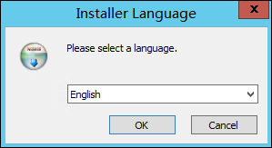

Select an installation language, and click **OK**.

The installation wizard is displayed, as shown in Figure 2-2.

Installation wizard

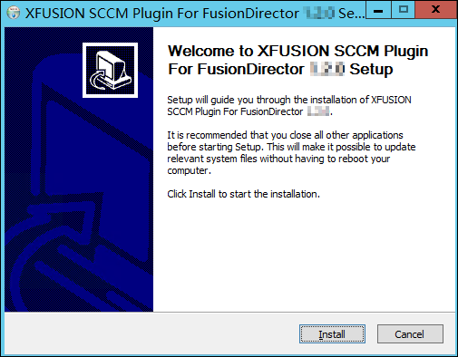

Click **Install**.

The SCCM plug-in installation starts, as shown in Figure 2-3.

Installation progress

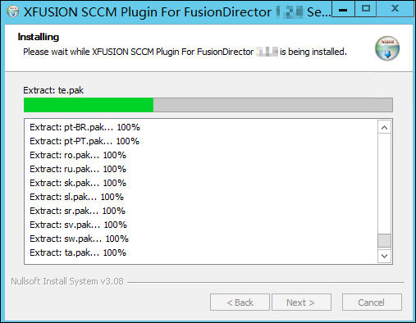

When the installation is complete, the window shown in Figure 2-4 is displayed.

Installation completed

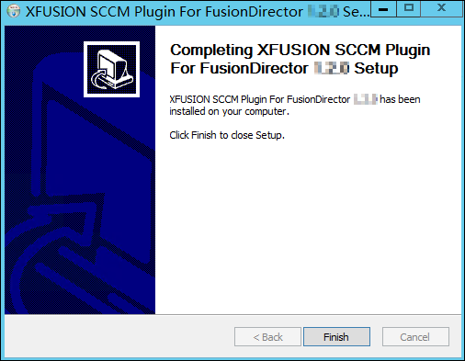

Click **Finish**.

The installation is complete.

----End

## Uninstalling the SCCM Plug-in

You can use either of the following methods to uninstall the plug-in:

* Uninstalling the SCCM plug-in from the Control Panel.
* Uninstalling the SCCM plug-in from the SCCM plug-in installation directory.

Uninstalling the SCCM plug-in from the Control Panel

Log in to the server.

Uninstall the SCCM plug-in.

1. Choose **Start** > **Control Panel** > **Programs > Programs and Features**.

The **Programs and Features** window is displayed, as shown in Figure 2-5.

Programs and Features

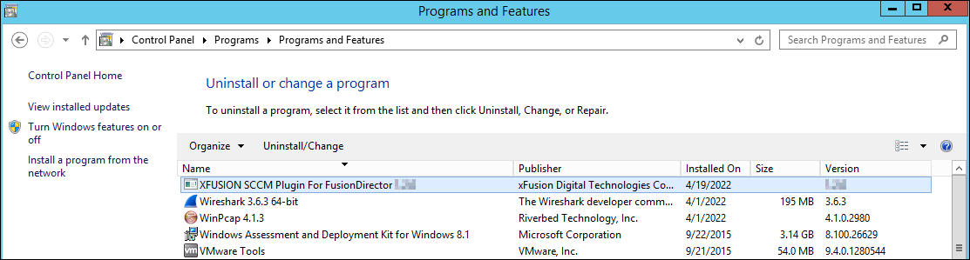

1. Find the SCCM plug-in (such as **XFUSION SCCM Plugin For FusionDirector** *X.X.X***.exe**) and double-click it.

The confirmation dialog box is displayed, as shown in Figure 2-6.

Dialog box

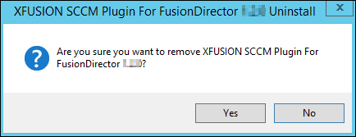

1. Confirm the uninstallation, and click **Yes**.

The SCCM plug-in uninstallation starts, and a dialog box prompting you to confirm data deletion is displayed, as shown in Figure 2-7.

Dialog box

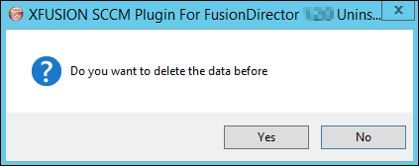

1. Confirm the data deletion, and click **Yes**.

A dialog box indicating successful uninstallation is displayed, as shown in Figure 2-8.

Dialog box

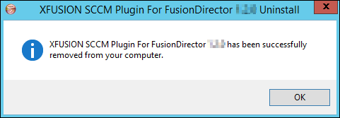

1. Click **OK**.

The plug-in is uninstalled successfully.

----End

Uninstalling the SCCM plug-in from the SCCM plug-in installation directory.

Log in to the server.

Uninstall the SCCM plug-in.

1. Go to the SCCM plug-in installation directory, as shown in Figure 2-9.

Going to the XFUSION SCCM plug-in installation directory

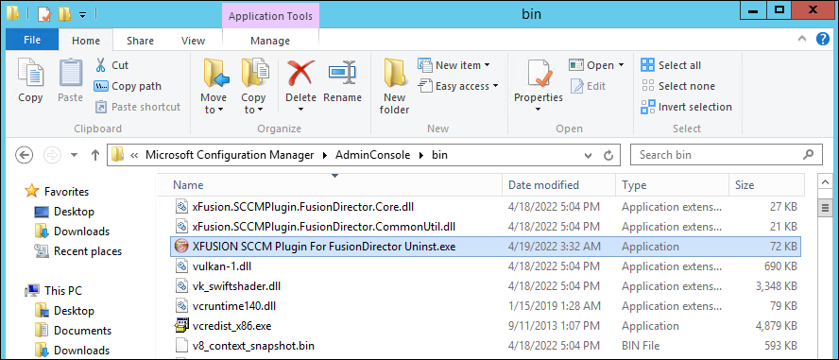

1. Find the **XFUSION SCCM Plugin For FusionDirector Uninst.exe** and double-click it.

The confirmation dialog box is displayed, as shown in Figure 2-10.

Dialog box



1. Confirm the uninstallation, and click **Yes**.

The SCCM plug-in uninstallation starts, and a dialog box prompting you to confirm data deletion is displayed, as shown in Figure 2-11.

Dialog box



1. Confirm the data deletion, and click **Yes**.

A dialog box indicating successful uninstallation is displayed, as shown in Figure 2-12.

Dialog box



1. Click **OK**.

The plug-in is uninstalled successfully.

----End

# Operation and Maintenance

3.1 Configuring FusionDirector

3.2 Viewing the Server List

3.3 Deploying an OS

3.4 Configuring a Server Using a Profile

3.5 Upgrading Firmware and Drivers

3.6 Managing Tasks

3.7 Viewing the SCCM Plug-in Version

## Configuring FusionDirector

### Adding FusionDirector

Log in to the server.

Choose **Start** > **Configuration Manager Console** to log in to the SCCM.



If **Configuration Manager Console** cannot be found on the **Start** panel, return to the desktop, right-click **Start**, choose **Search** from the shortcut menu, and enter **Configuration Manager Console** in the search box to find **Configuration Manager Console**.

The SCCM main window is displayed, as shown in Figure 3-1.

SCCM main window

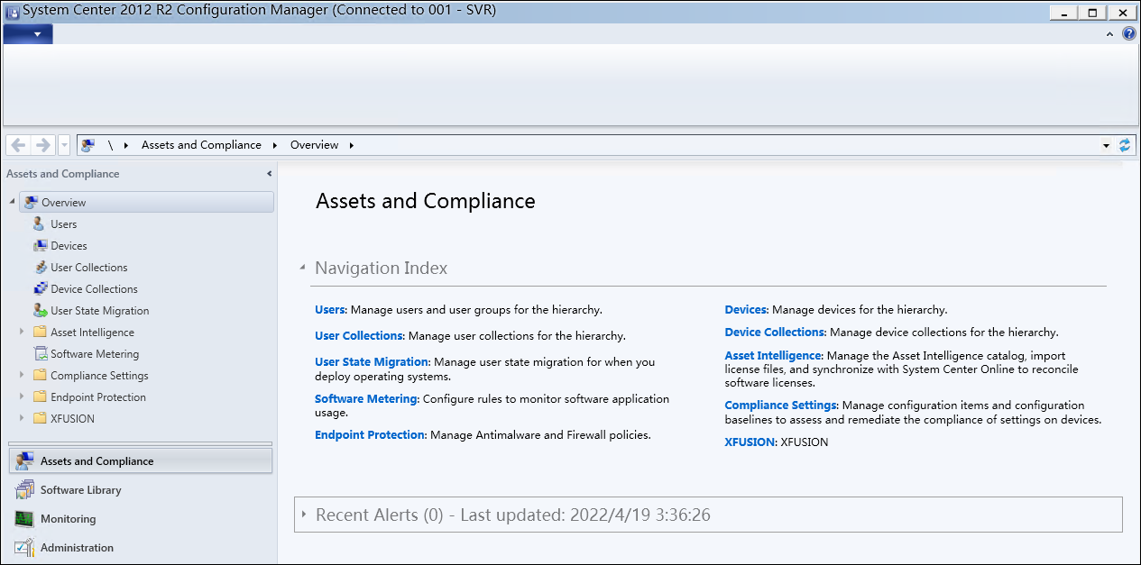

Choose **XFUSION** > **FusionDirector Setting**.

The **FusionDirector Setting** window is displayed, as shown in Figure 3-2.

FusionDirector Setting

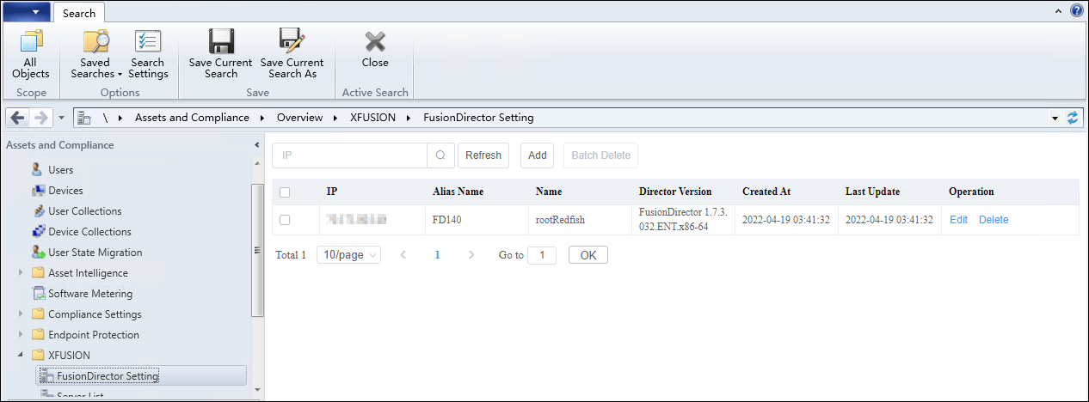

Click **Add**.

The **Add FusionDirector** window is displayed, as shown in Figure 3-3.

Add FusionDirector

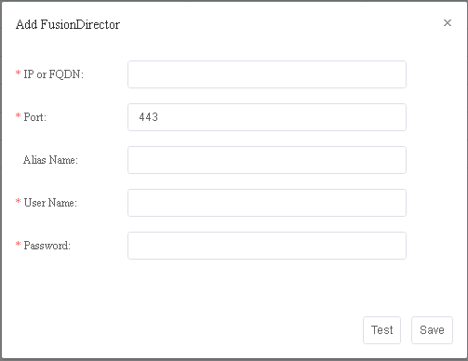

Table 3-1 describes the parameters.

Parameter description

| Parameter | Description | Mandatory |
| --- | --- | --- |
| IP or FQDN | FusionDirector IP address or domain name | Yes |
| Port | FusionDirector northbound port number. The default value is **443**. | Yes |
| Alias Name | Customized FusionDirector name. The value contains 1 to 100 characters and supports letters, digits, underscores, em dashes (**—**), and dots (.). | No |
| User Name | FusionDirector northbound port user name. The default value is **rootRedfish**. | Yes |
| Password | FusionDirector northbound port password. | Yes |

Enter FusionDirector information according to Table 3-1, and click **Test** to check whether the configuration information is correct.

If "Link test successfully" is displayed in the window, the entered FusionDirector information is correct. If any error occurs, enter FusionDirector information again.

Click **Save**.

A dialog box indicating successful adding is displayed, as shown in Figure 3-4.

Dialog box

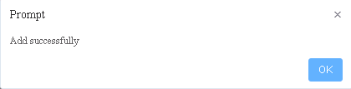

Click **OK**.

The FusionDirector is added successfully.

----End

### Editing FusionDirector

Log in to the server.

Choose **Start** > **Configuration Manager Console** to log in to the SCCM.



If **Configuration Manager Console** cannot be found on the **Start** panel, return to the desktop, right-click **Start**, choose **Search** from the shortcut menu, and enter **Configuration Manager Console** in the search box to find **Configuration Manager Console**.

The SCCM main window is displayed, as shown in Figure 3-5.

SCCM main window



Choose **XFUSION** > **FusionDirector Setting**.

The **FusionDirector Setting** window is displayed, as shown in Figure 3-6.

FusionDirector Setting



Click **Edit** in the row where the FusionDirector to be edited is located.

The **Edit FusionDirector** window is displayed, as shown in Figure 3-7.

Edit FusionDirector

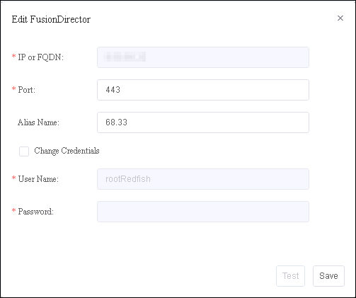

Edit FusionDirector information according to Table 3-1, and click **Save**.



* The FusionDirector IP address cannot be modified.
* **Change Credentials** must be selected if the FusionDirector user name and password are to be changed.

A dialog box indicating successful editing is displayed, as shown in Figure 3-8.

Dialog box

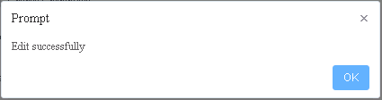

Click **OK**.

The FusionDirector is edited successfully.

----End

### Deleting FusionDirector

Log in to the server.

Choose **Start** > **Configuration Manager Console** to log in to the SCCM.



If **Configuration Manager Console** cannot be found on the **Start** panel, return to the desktop, right-click **Start**, choose **Search** from the shortcut menu, and enter **Configuration Manager Console** in the search box to find **Configuration Manager Console**.

The SCCM main window is displayed, as shown in Figure 3-9.

SCCM main window



Choose **XFUSION** > **FusionDirector Setting**.

The **FusionDirector Setting** window is displayed, as shown in Figure 3-10.

FusionDirector Setting



Click **Delete** in the row where the FusionDirector is located.

The confirmation dialog box is displayed, as shown in Figure 3-11.

Dialog box

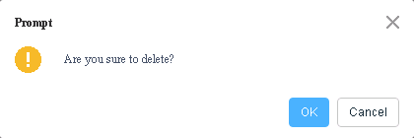

You can select multiple FusionDirector systems and click **Batch Delete** to delete them in batches.

Click **OK**.

The FusionDirector is deleted successfully.

----End

## Viewing the Server List

Log in to the server.

Choose **Start** > **Configuration Manager Console** to log in to the SCCM.



If **Configuration Manager Console** cannot be found on the **Start** panel, return to the desktop, right-click **Start**, choose **Search** from the shortcut menu, and enter **Configuration Manager Console** in the search box to find **Configuration Manager Console**.

The SCCM main window is displayed, as shown in Figure 3-12.

SCCM main window



Choose **XFUSION** > **Server List**.

The **Server List** window is displayed, as shown in Figure 3-13.

Server List

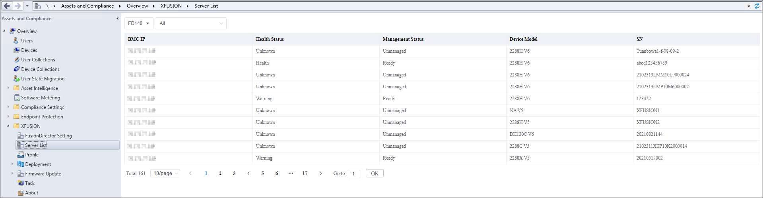

You can view the servers managed by each FusionDirector system in this window.



* **test1** in Figure 3-13 indicates the FusionDirector alias. You can select another FusionDirector system from the drop-down list box.
* **All** in Figure 3-13 indicates that all servers are viewed. You can select a server from the drop-down list.

----End

## Deploying an OS

### Managing OS Images

Scenario

To deploy an OS on a server, you need to add an OS image, add an OS template, and add an OS deployment task.

Prerequisites

A standard OS image in the ISO format has been downloaded to the local PC.

Procedure

Log in to the server.

Choose **Start** > **Configuration Manager Console** to log in to the SCCM.



If **Configuration Manager Console** cannot be found on the **Start** panel, return to the desktop, right-click **Start**, choose **Search** from the shortcut menu, and enter **Configuration Manager Console** in the search box to find **Configuration Manager Console**.

The SCCM main window is displayed, as shown in Figure 3-14.

SCCM main window



Choose **XFUSION** > **Deployment** > **OS Image**.

The **OS Image** window is displayed, as shown in Figure 3-15.

OS Image

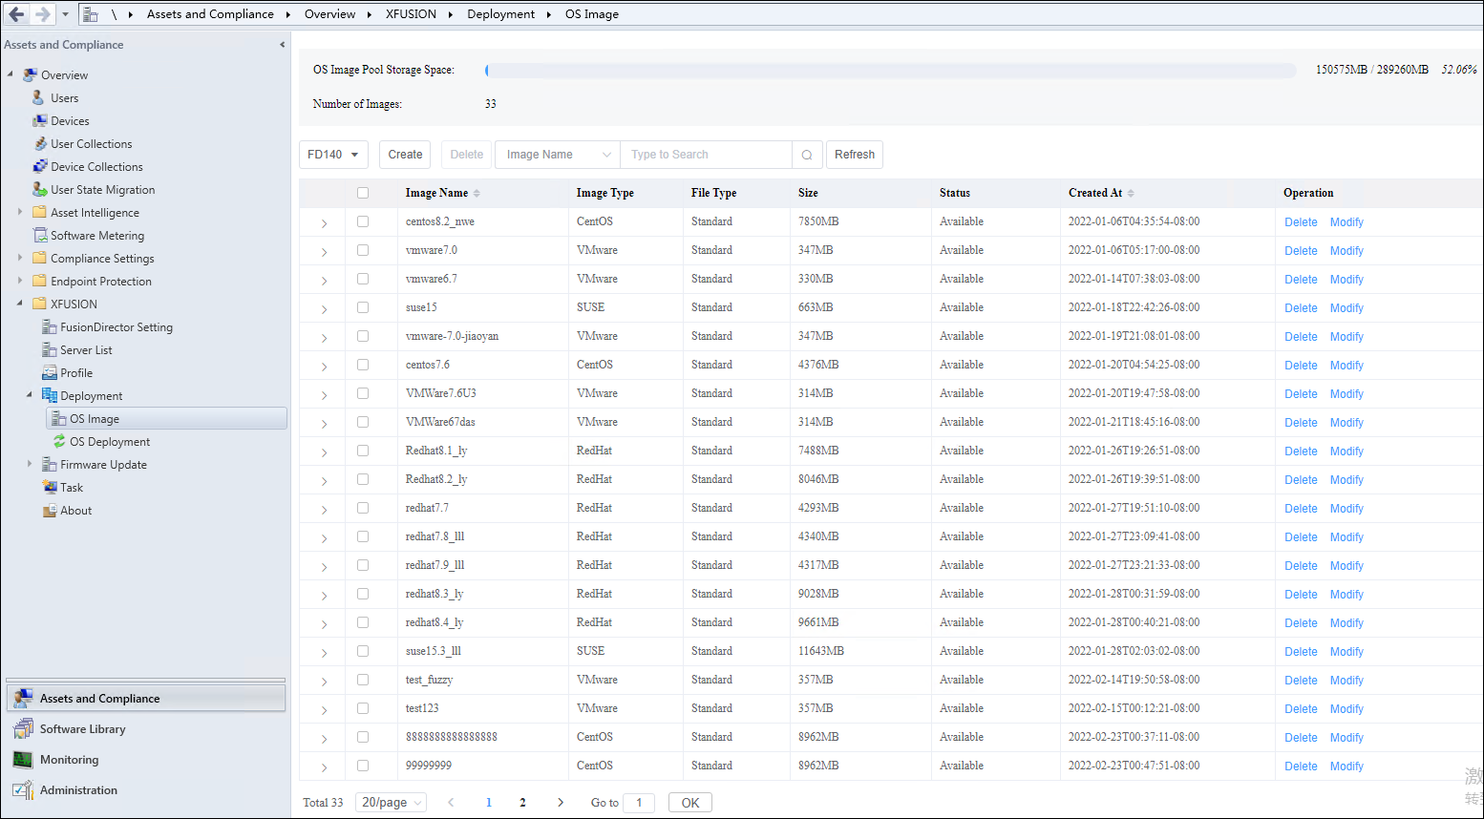

Click **Create**.

The page for creating an OS image is displayed, as shown in Figure 3-16.

Creating an OS image

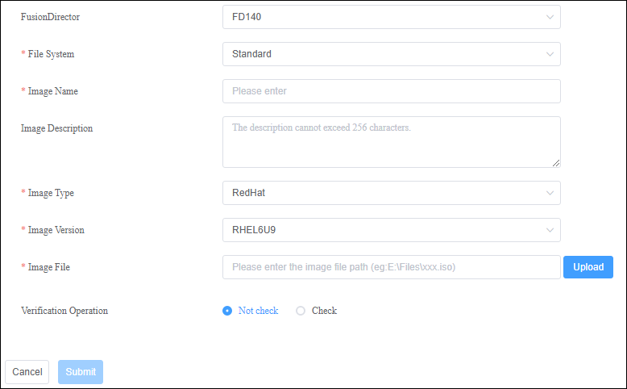

Table 3-2 describes the parameters.

Parameter description

| Parameter | Description | Value | Mandatory |
| --- | --- | --- | --- |
| FusionDirector | FusionDirector ID. | ID of a FusionDirector that has been added. | Yes |
| File System | Image file type. | The value can be only **Standard** currently. | Yes |
| Image Name | Image name. | The value contains 1 to 32 characters, including only letters, digits, hyphens (-), underscores (_), and dots (.). | Yes |
| Image Description | OS image description. | The value contains 0 to 256 characters. | No |
| Image Type | OS image type. | For details,see [FusionDirector Operation Guide](https://support.xfusion.com/support/#/en/fusiondirector/fusiondirector-pid-23015464/document?category=C12). | Yes |
| Image Version | Software source version. | A software source type includes one or multiple versions. For details,see [FusionDirector Operation Guide](https://support.xfusion.com/support/#/en/fusiondirector/fusiondirector-pid-23015464/document?category=C12). | Yes |
| Image File | Image file path. | The local file path must contain **.iso**. | Yes |
| Verification Operation | Whether to perform verification. | The value is **Not check** or **Check**. Two encryption modes are available for **Check**, SHA256 and MD5. | Yes |

Click **Submit**. The OS image is added successfully.

Click **Refresh** to refresh the window. Then you can view the added OS image in the OS image list, as shown in Figure 3-17.

OS image list



* If the OS image fails to be created, you can view the task failure information on the **Task** page.
* You can click **Delete** or **Modify** in the row where an OS image is located to delete or modify the OS image.

----End

### Adding an OS Template

Log in to the server.

Choose **Start** > **Configuration Manager Console** to log in to the SCCM.



If **Configuration Manager Console** cannot be found on the **Start** panel, return to the desktop, right-click **Start**, choose **Search** from the shortcut menu, and enter **Configuration Manager Console** in the search box to find **Configuration Manager Console**.

The SCCM main window is displayed, as shown in Figure 3-18.

SCCM main window



Choose **XFUSION** > **Deployment** > **OS Deployment**.

The **OS Deployment** window is displayed, as shown in Figure 3-19.

OS Deployment

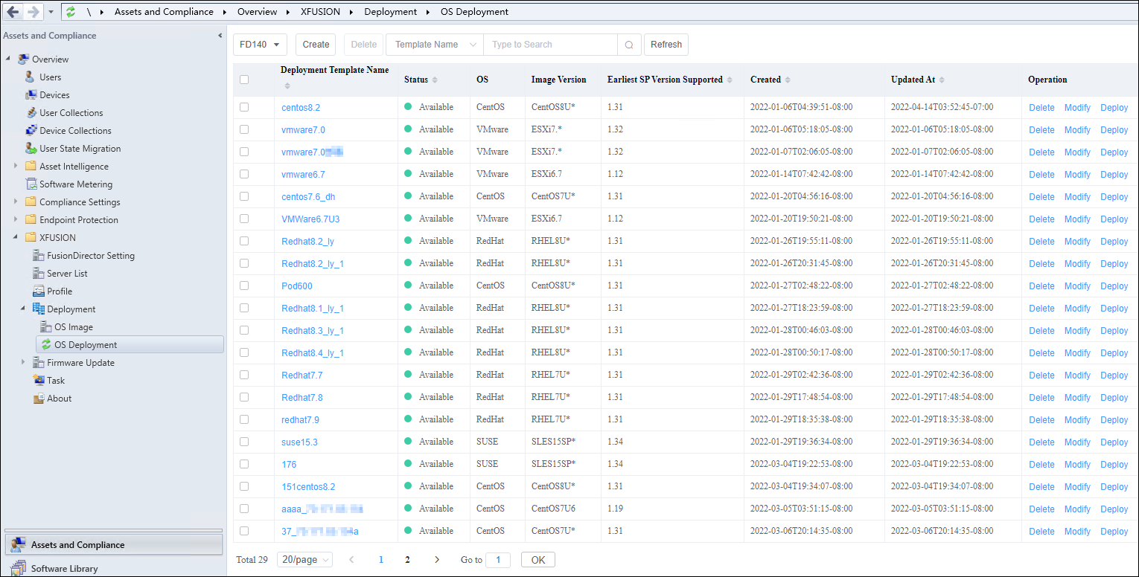

Click **Create**.

The page for creating an OS deployment template is displayed, as shown in Figure 3-20.

Table 3-3 describes the parameters.



The **Installation Information** area is displayed only after you select an OS image in the **Basic Information** area.

Creating an OS deployment template

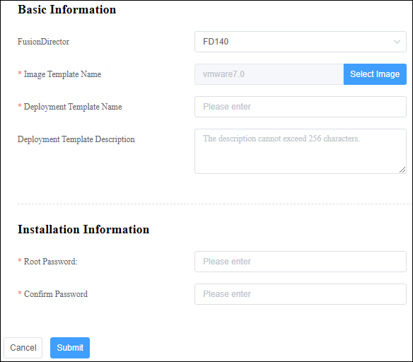

Parameter description

| Parameter | Description | Value | Mandatory |
| --- | --- | --- | --- |
| Fusion Director | FusionDirector ID. | ID of a FusionDirector that has been added. | Yes |
| Image Template Name | Image name. | The name of an OS image that has been created in the system. You can click **Select Image** to select an OS image. | Yes |
| Deployment Template Name | Name of the deployment template. | The value contains 1 to 32 characters, including letters, digits, hyphens (-), underscores (_), and dots (.). | Yes |
| Deployment Template Description | Template description. | The value contains 0 to 256 characters. | No |
| Root Password | OS administrator password. | The value contains 6 to 32 characters and must consist of at least two types of the following characters: uppercase letters, lowercase letters, digits, and special characters (`~!@$%......&*()-_=+|[{}];:' ",<.>/? #). | Yes |
| Confirm Password | Password for confirmation. | The value needs to be the same as the configured OS administrator password. | Yes |

Click **Submit**.

The OS template is added successfully, and you can view the added OS template in the template list, as shown in Figure 3-21.

Template list

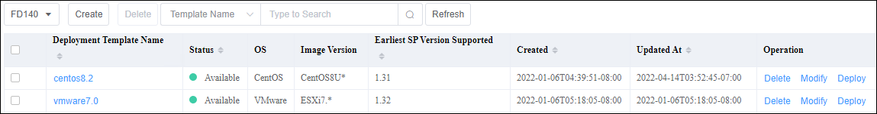

* If there are many OS images, you can filter images by image name.
* To delete or modify a template, click **Delete** or **Modify** in the row where the template is located.

----End

### Deploying an OS Using a Template

OS templates can be used to deploy OSs on managed servers in batches, improving deployment efficiency.

Procedure

Log in to the server.

Choose **Start** > **Configuration Manager Console** to log in to the SCCM.



If **Configuration Manager Console** cannot be found on the **Start** panel, return to the desktop, right-click **Start**, choose **Search** from the shortcut menu, and enter **Configuration Manager Console** in the search box to find **Configuration Manager Console**.

The SCCM main window is displayed, as shown in Figure 3-22.

SCCM main window



Choose **XFUSION** > **Deployment** > **OS Deployment**.

The **OS Deployment** window is displayed, as shown in Figure 3-23.

OS Deployment



Select a deployment template to deploy the OS.

1. Click **Deploy**.

The template deployment page is displayed, as shown in Figure 3-24.

OS Deployment

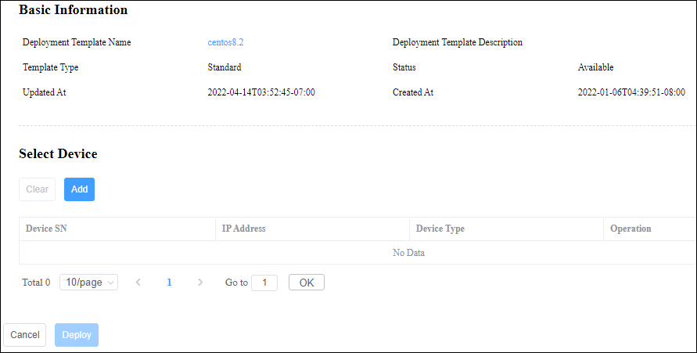

1. In the **Select Device** area, click **Add**.

The **Add New Device** dialog box is displayed.

1. Select the server where the OS is to be deployed and click **OK**, as shown in Figure 3-25.

Add New Device dialog box

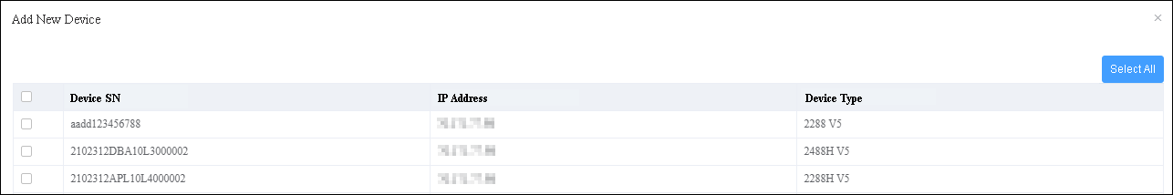

1. In the **OS Deployment** window, click **Deploy** to start the deployment task.

You can view the deployment progress on the **Task** page. If the task status is **Successful**, the deployment is successful.

----End

## Configuring a Server Using a Profile

Servers can be configured in batches using a profile, greatly improving server configuration efficiency. The current profiles can be used to configure the server BIOS, RAID, and BMC.

### Creating a Server Profile

Log in to the server.

Choose **Start** > **Configuration Manager Console** to log in to the SCCM.



If **Configuration Manager Console** cannot be found on the **Start** panel, return to the desktop, right-click **Start**, choose **Search** from the shortcut menu, and enter **Configuration Manager Console** in the search box to find **Configuration Manager Console**.

The SCCM main window is displayed, as shown in Figure 3-26.

SCCM main window



Choose **XFUSION** > **Profile**.

The server profile management page is displayed, as shown in Figure 3-27.

Server profile management page

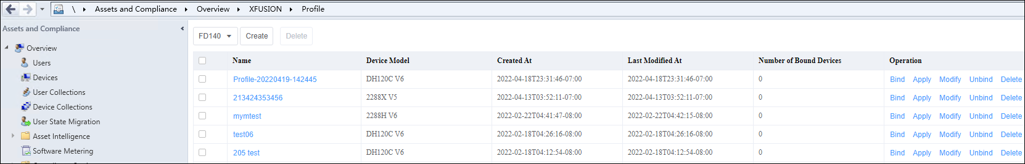

Click **Create**.

The page for creating a server profile is displayed, as shown in Figure 3-28. Table 3-4 describes the parameters.



**BIOS Configuration**, **RAID Configuration**, and **BMC Configuration** are displayed only after **Device Model** is selected.

Creating a server profile

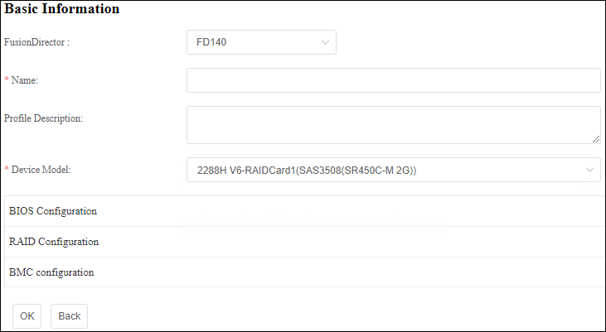

Server profile parameters

| Parameter | Description | Value | Mandatory |
| --- | --- | --- | --- |
| FusionDirector | FusionDirector ID. | ID of a FusionDirector that has been added. | Yes |
| Name | Profile name. | The value contains 1 to 45 characters, including letters, digits, underscores (_), hyphens (-), and spaces. | Yes |
| Profile Description | Profile description. | The value contains 0 to 1024 characters. | No |
| Device Model | Device type. | The type of the device that has been managed by the system. It is automatically determined by the device managed by the system. | Yes |
| BIOS Configuration | BIOS configuration. | BIOS configurations include **Boot**, **Boot Sequence**, **Advanced Power Management Configuration**, **Intel VT for Directed I/O(VT-D)**, **Processor Configuration**, **Memory Configuration**, **Console Redirection**, **iBMC Configuration**, **PXE Configuration**, **UPI Configuration**, **Power** and **IIO Configuration**. For details, see [FusionDirector Operation Guide](https://support.xfusion.com/support/#/en/fusiondirector/fusiondirector-pid-23015464/document?category=C12). | Yes |
| RAID Configuration | RAID configuration. | You can delete existing logical disks and create logical disks. For details, see [FusionDirector Operation Guide](https://support.xfusion.com/support/#/en/fusiondirector/fusiondirector-pid-23015464/document?category=C12). | Yes |
| BMC Configuration | BMC configuration. | You can perform the BMC NTP, DNS, and LDAP configurations. For details, see [FusionDirector Operation Guide](https://support.xfusion.com/support/#/en/fusiondirector/fusiondirector-pid-23015464/document?category=C12). | Yes |

Click **OK**.

The file is created.

----End

### Querying Server Profiles

Log in to the server.

Choose **Start** > **Configuration Manager Console** to log in to the SCCM.



If **Configuration Manager Console** cannot be found on the **Start** panel, return to the desktop, right-click **Start**, choose **Search** from the shortcut menu, and enter **Configuration Manager Console** in the search box to find **Configuration Manager Console**.

The SCCM main window is displayed, as shown in Figure 3-29.

SCCM main window



Choose **XFUSION** > **Profile**.

The server profile page is displayed, as shown in Figure 3-30. You can view the list of server profiles that have been created in the system.

Querying server profiles



Click the name of a specified server profile.

The server profile details are displayed, as shown in Figure 3-31.

Server profile details

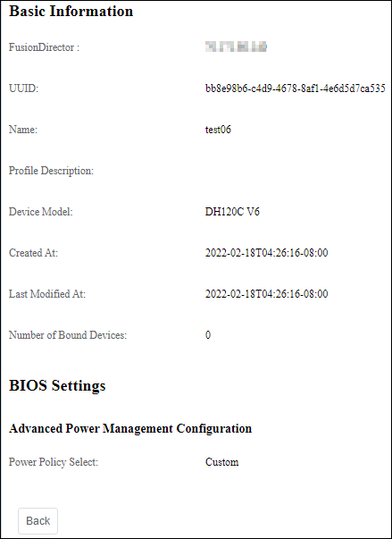

----End

### Modifying a Server Profile

After a server profile is added, you can modify the server profile.

Log in to the server.

Choose **Start** > **Configuration Manager Console** to log in to the SCCM.



If **Configuration Manager Console** cannot be found on the **Start** panel, return to the desktop, right-click **Start**, choose **Search** from the shortcut menu, and enter **Configuration Manager Console** in the search box to find **Configuration Manager Console**.

The SCCM main window is displayed, as shown in Figure 3-32.

SCCM main window



Choose **XFUSION** > **Profile**.

The server profile page is displayed, as shown in Figure 3-33. You can view the list of server profiles that have been created in the system.

Viewing server profiles



Click **Modify** in the **Operation** column of a specified server profile.

The page for modifying the server profile is displayed, as shown in Figure 3-34.

Modifying the server profile

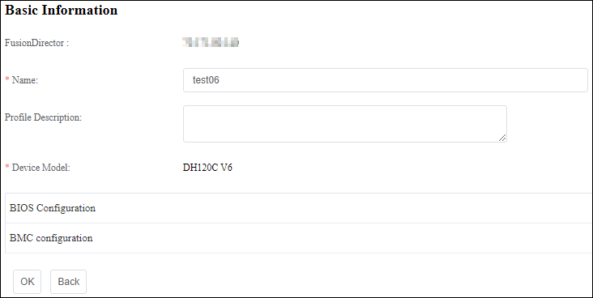

Click **OK**.

The server profile is modified successfully.

----End

### Configuring Servers Using a Server Profile

After a server profile is added, you can use the server profile to configure the managed servers.

Log in to the server.

Choose **Start** > **Configuration Manager Console** to log in to the SCCM.



If **Configuration Manager Console** cannot be found on the **Start** panel, return to the desktop, right-click **Start**, choose **Search** from the shortcut menu, and enter **Configuration Manager Console** in the search box to find **Configuration Manager Console**.

The SCCM main window is displayed, as shown in Figure 3-35.

SCCM main window



Choose **XFUSION** > **Profile**.

The server profile page is displayed, as shown in Figure 3-36. You can view the list of server profiles that have been created in the system.

Querying server profiles



Click **Bind** in the **Operation** column of a specified server profile.

On the displayed page, select a device to which the server profile is to be bound, as shown in Figure 3-37.

Binding the server profile to a device

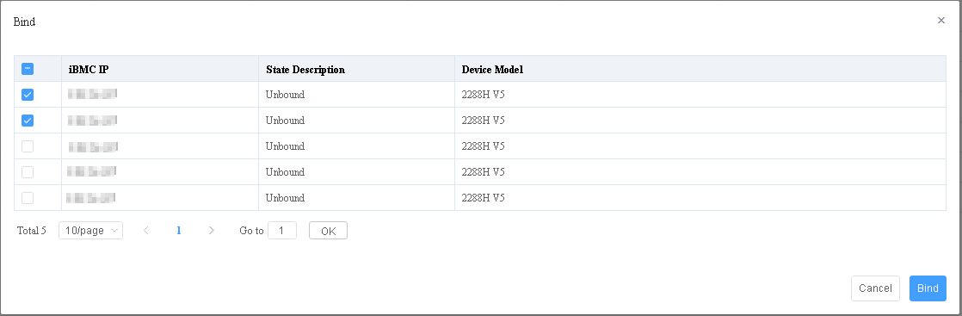

Click **Bind**.

The device is bound.

View the information about the bound device.

Go to the configuration query page and check the number of devices bound to the server profile, as shown in Figure 3-38.

Number of Bound Devices

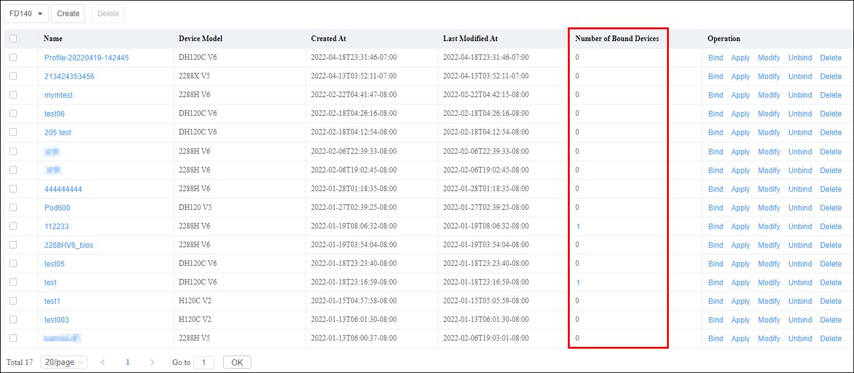

Click the number in the **Number of Bound Devices** column to view the information about the bound device, as shown in Figure 3-39.

Information about the bound device

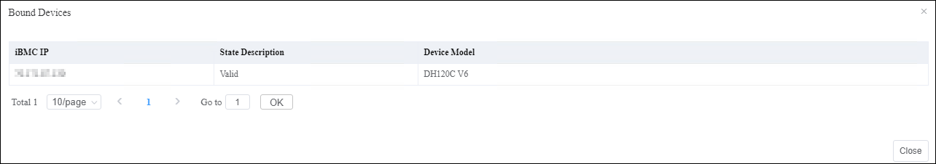

Click **Apply** in the **Operation** column of the server profile.

The page for applying the server profile is displayed, as shown in Figure 3-40. View the selected device to which the configuration is to be delivered.

Information about the bound device

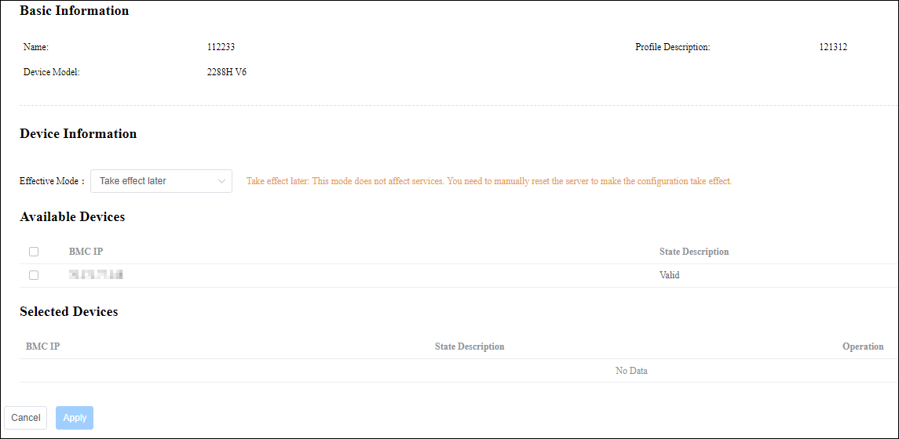

Click **Apply**.

After the configuration delivery is started, you can view the configuration delivery status in the task list.

----End

### Deleting a Server Profile

Delete a server profile that is no longer used. Before deleting a profile, ensure that the profile is not bound to any device.

Log in to the server.

Choose **Start** > **Configuration Manager Console** to log in to the SCCM.



If **Configuration Manager Console** cannot be found on the **Start** panel, return to the desktop, right-click **Start**, choose **Search** from the shortcut menu, and enter **Configuration Manager Console** in the search box to find **Configuration Manager Console**.

The SCCM main window is displayed, as shown in Figure 3-41.

SCCM main window



Choose **XFUSION** > **Profile**.

The server profile page is displayed, as shown in Figure 3-42. You can view the list of server profiles that have been created in the system.

Querying server profiles

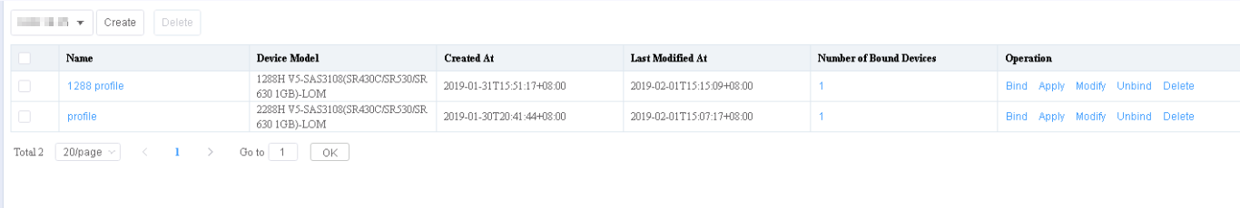

Click **Unbind**.

The page for unbinding a server profile is displayed, as shown in Figure 3-43.

Select the device to be unbound. Click **Unbind** to unbind the device.

Unbinding the device

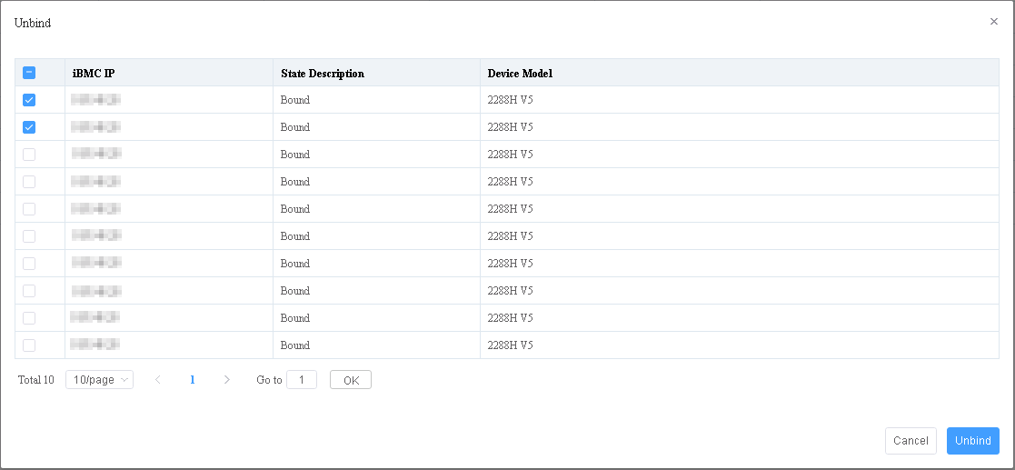

On the server profile page, click **Delete** in the **Operation** column of the server profile to be deleted.

The page for confirming the deletion of the server profile is displayed, as shown in Figure 3-44.

Click **OK**. The server profile is deleted successfully.

Confirming the deletion

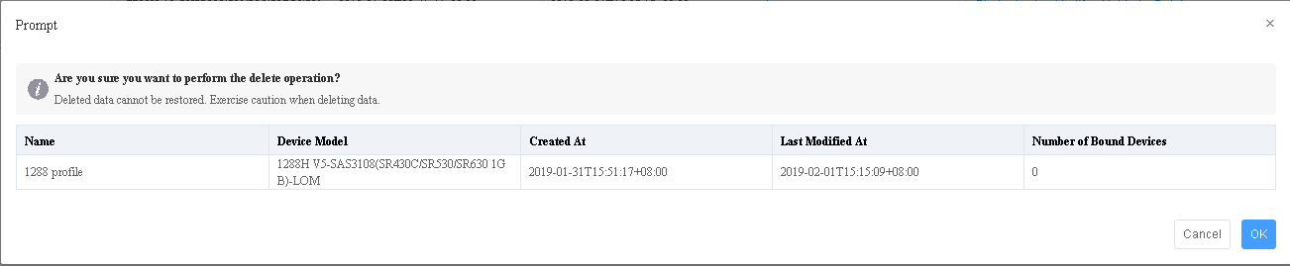

----End

## Upgrading Firmware and Drivers

* Upgrade for the out-of-band firmware BMC, BIOS, and CPLD is supported.
* Upgrade for the in-band firmware RAD controller card and NIC is supported.
* Upgrade for the Smart Provisioning firmware, power supply firmware, and drivers is supported.

### Version Repository Management

#### Uploading an Update Package

Prerequisites

* To upgrade the in-band firmware, the Smart Provisioning version must be 1.18 or later.
* You have obtained the software packages and digital signatures from [Support website](https://support.xfusion.com/support/#/en/home).

Automatically Obtaining an Update Package

Log in to the server.

Choose **Start** > **Configuration Manager Console** to log in to the SCCM.



If **Configuration Manager Console** cannot be found on the **Start** panel, return to the desktop, right-click **Start**, choose **Search** from the shortcut menu, and enter **Configuration Manager Console** in the search box to find **Configuration Manager Console**.

The SCCM main window is displayed, as shown in Figure 3-45.

SCCM main window



Choose **XFUSION > Firmware Update** > **Version Repository**.

The **Baseline** page is displayed, as shown in Figure 3-46.

Baseline

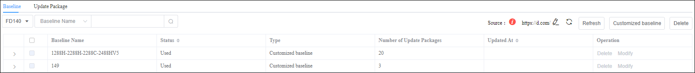

Select a FusionDirector system.

Click and enter the source of the software package, as shown in Figure 3-47.



Source

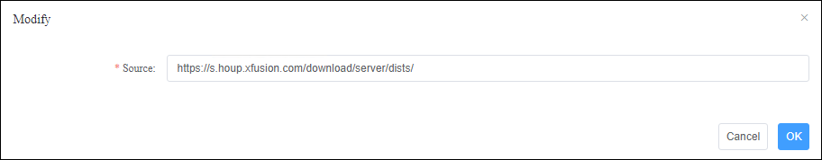

Click **OK**.

* : indicates that the connection to the online address fails. Rectify the fault according to the handling suggestions.



* 1. Check whether the website is correct.
  2. Check whether the DNS or proxy is available.

If the problem persists, contact technical support.

* : indicates that the online address can be accessed. FusionDirector automatically synchronizes the update package and baseline from the online address in the background. SCCM automatically obtains the update package and baseline synchronized from FusionDirector.



Click **>** next to a baseline name to view the automatically obtained update package and baseline.

Click the **Update Package** tab. On the page, view the automatically obtained update package.

----End

Manually Uploading an Update Package

Log in to the server.

Choose **Start** > **Configuration Manager Console** to log in to the SCCM.



If **Configuration Manager Console** cannot be found on the **Start** panel, return to the desktop, right-click **Start**, choose **Search** from the shortcut menu, and enter **Configuration Manager Console** in the search box to find **Configuration Manager Console**.

The SCCM main window is displayed, as shown in Figure 3-48.

SCCM main window



Choose **XFUSION > Firmware Update** > **Version Repository**. Click the **Update Package** tab.

The **Update Package** page is displayed, as shown in Figure 3-49.

Update package

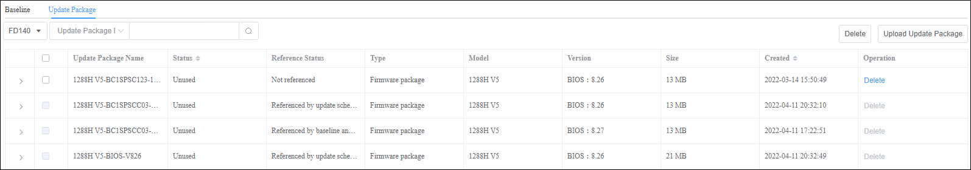

Click **Upload Update Package**.

The **Upload Update Package** page is displayed. Set the following parameters, as shown in Figure 3-50.

Uploading an update package

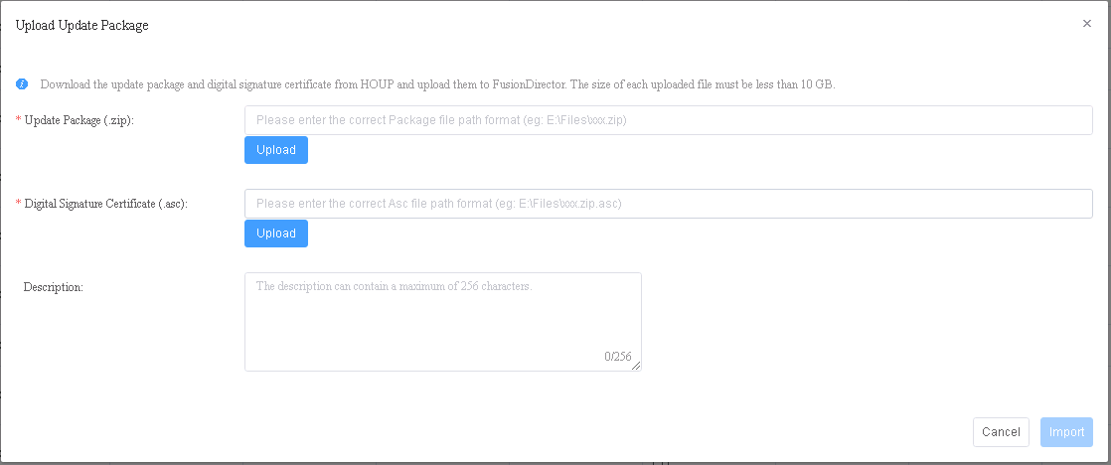

* **Update Package (.zip)**: Enter the path of the local update package and upload the update package in .zip format.
* **Digital Signature Certificate (.asc)**: Enter the path of the local digital signature file and upload the digital signature certificate file in .asc format.
* **Description**: indicates the update package description.

Click **Import**.

The update package is imported.

You can view the uploaded update packages on the **Update Package** page, as shown in Figure 3-51.

Update package

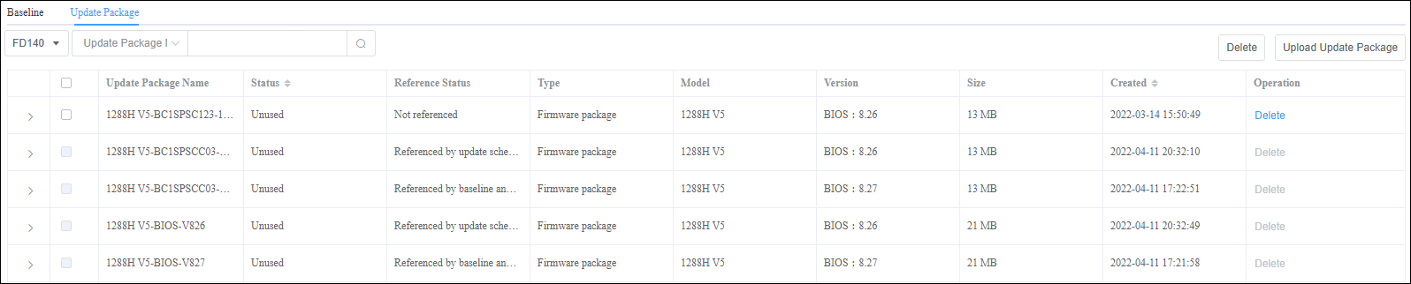

To delete an uploaded update package, click **Delete** in the **Operation** column. The package which is referenced by the baseline or is being used cannot be deleted.

----End

#### Customizing a Baseline

Automatically Obtaining a Baseline

Log in to the server.

Choose **Start** > **Configuration Manager Console** to log in to the SCCM.



If **Configuration Manager Console** cannot be found on the **Start** panel, return to the desktop, right-click **Start**, choose **Search** from the shortcut menu, and enter **Configuration Manager Console** in the search box to find **Configuration Manager Console**.

The SCCM main window is displayed, as shown in Figure 3-52.

SCCM main window



Choose **XFUSION > Firmware Update** > **Version Repository**.

The **Baseline** page is displayed, as shown in Figure 3-53.

Baseline



Select a FusionDirector system.

Click and enter the source of the baseline, as shown in Figure 3-54.



Source



Click **OK**.

* : indicates that the connection to the online address fails. Rectify the fault according to the handling suggestions.



* 1. Check whether the website is correct.
  2. Check whether the DNS or proxy is available.

If the problem persists, contact technical support.

* : indicates that the online address can be accessed. FusionDirector automatically synchronizes the update package and baseline from the online address in the background. SCCM automatically obtains the update package and baseline synchronized from FusionDirector.



Click **>** next to a baseline name to view the automatically obtained update package and baseline.

----End

Manually Customizing a Baseline

Log in to the server.

Choose **Start** > **Configuration Manager Console** to log in to the SCCM.



If **Configuration Manager Console** cannot be found on the **Start** panel, return to the desktop, right-click **Start**, choose **Search** from the shortcut menu, and enter **Configuration Manager Console** in the search box to find **Configuration Manager Console**.

The SCCM main window is displayed, as shown in Figure 3-55.

SCCM main window



Choose **XFUSION > Firmware Update** > **Version Repository**.

The **Baseline** page is displayed, as shown in Figure 3-56.

Baseline



Click **Customized baseline**.

The **Customized baseline** page is displayed. Set the following parameters, as shown in Figure 3-57.

Customizing a baseline

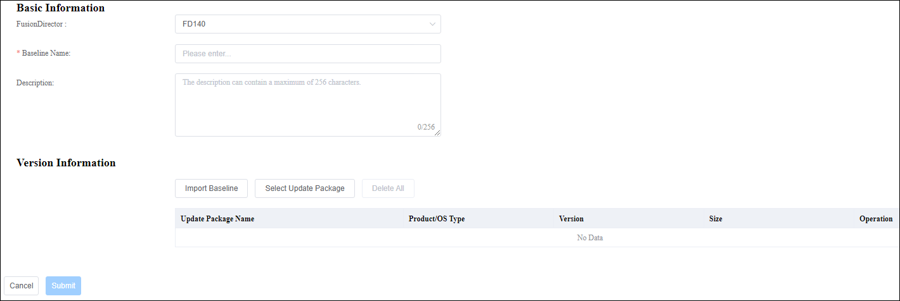

* **FusionDirector**: selects a FusionDirector system.
* **Baseline Name**: indicates the baseline name.
* **Description**: indicates the baseline description.
* **Version Information**: imports an existing baseline or update package.
* **Import Baseline**: selects the created baselines to form an update package for the customized baseline.
* **Select Update Package**: selects the uploaded update packages to form an update package for the customized baseline.

Click **Submit**.

The baseline is created.

You can view the created baselines on the **Baseline** page, as shown in Figure 3-58.

Baseline

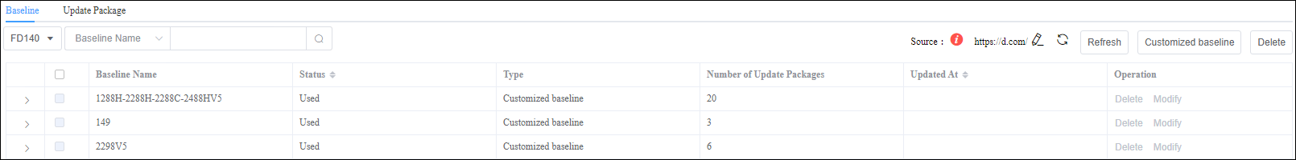

----End

### Update Schedule Management

#### Creating an Update Schedule

Log in to the server.

Choose **Start** > **Configuration Manager Console** to log in to the SCCM.



If **Configuration Manager Console** cannot be found on the **Start** panel, return to the desktop, right-click **Start**, choose **Search** from the shortcut menu, and enter **Configuration Manager Console** in the search box to find **Configuration Manager Console**.

The SCCM main window is displayed, as shown in Figure 3-59.

SCCM main window



Choose **XFUSION > Firmware Update** > **Update Schedule**.

The **Update Schedule** page is displayed, as shown in Figure 3-60.

Update schedule



Click **Create Schedule**.

On the **Select Device** page, set the parameters and select groups or devices, as shown in Figure 3-61.

Selecting devices

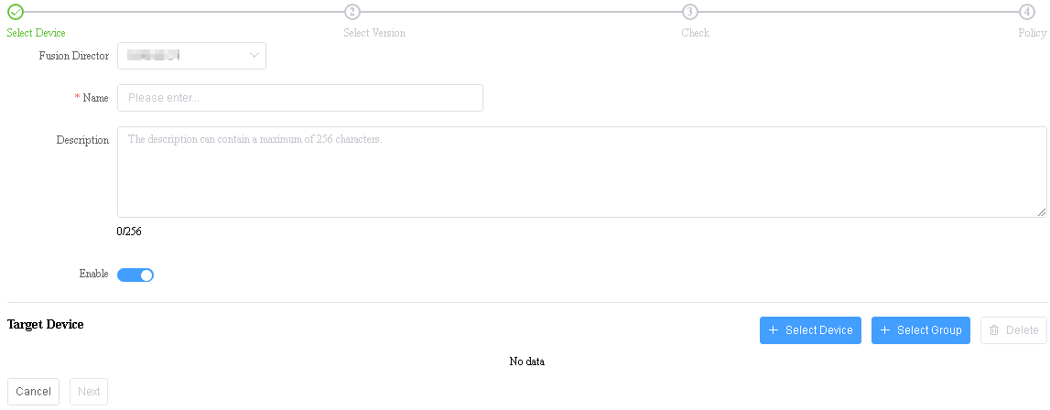

* **FusionDirector**: selects a FusionDirector system.
* **Name**: indicates the schedule name.



The value can contain 1 to 32 characters, including Chinese characters, letters, digits, hyphens (-), underscores (_), and dots (.).

* **Description**: indicates the schedule description.
* **Enable**: indicates whether to enable the update schedule. indicates that the schedule is enabled. indicates that the schedule is disabled.



* **Select Device**: You can click to select the device to be updated.



* You can select only one of **Select Device** and **Select Group**.
* To delete a device, click **Delete** on the right.
* **Select Group**: You can click to select the group to be updated.



Private groups created on FusionDirector are invisible on the SCCM. To make all groups visible, ensure that all groups are set to non-private groups when they are created.



* You can select only one of **Select Device** and **Select Group**.
* To delete a group, click **Delete** on the right.

Click **Next**.

The page for selecting baselines or update packages is displayed, as shown in Figure 3-62.

Selecting baselines or update packages

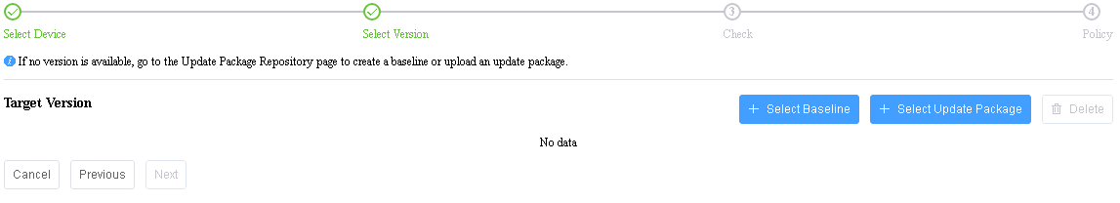

Click **Select Baseline** or **Select Update Package** to select the required update file.



* You can select only one of **Select Baseline** and **Select Update Package**.
* To delete a baseline or update package, click **Delete** on the right.

Click **Next**.

On the **Update Report** page, select the device to be updated, as shown in Figure 3-63.



* Click **>** on the left of the update report to view details about each update component.
* By default, firmware of the same version is not selected for update.
* By default, the in-band firmware and Smart Provisioning firmware is not selected for update.

Update report

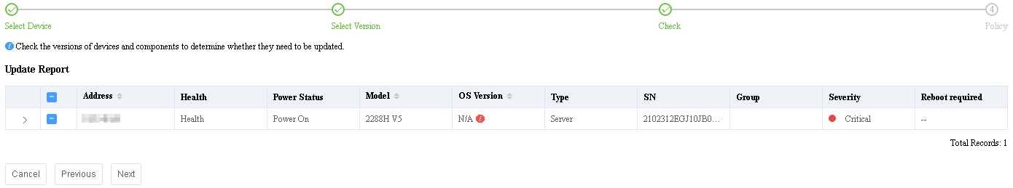

Click **Next**.

The **Policy** page is displayed, as shown in Figure 3-64.

Update policy

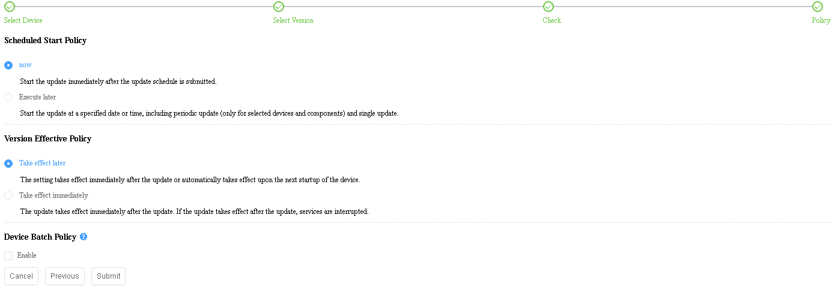

* **Schedule Start Policy**: selects the required scheduled start policy.
* **Update now**: After the schedule is submitted, the system updates the devices immediately.
* **Execute later**: After the schedule is submitted, the system executes the schedule at the specified date/time once or periodically for the selected devices and components. You can specify the week, date, or time for the update.
* **Version Effective Policy**: selects the required version effective policy.
* **Take effect later**: The update takes effect manually or takes effect upon the next startup of the device.



The BMC firmware update takes effect immediately even if you select **Take effect later**.

* **Take effect immediately**: The update takes effect immediately. If activation requires device restart, services will be interrupted
* **Device Batch Policy**: indicates whether to enable the device batch policy.

Click **Submit**.

The update schedule is created.

----End

#### Viewing the Update Schedule

Log in to the server.

Choose **Start** > **Configuration Manager Console** to log in to the SCCM.



If **Configuration Manager Console** cannot be found on the **Start** panel, return to the desktop, right-click **Start**, choose **Search** from the shortcut menu, and enter **Configuration Manager Console** in the search box to find **Configuration Manager Console**.

The SCCM main window is displayed, as shown in Figure 3-65.

SCCM main window



Choose **XFUSION > Firmware Update** > **Update Schedule**.

The **Update Schedule** page is displayed, as shown in Figure 3-66.

Update schedule

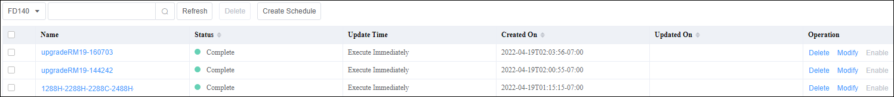

Click the name of the update schedule to view the details, as shown in Figure 3-67.

Detailed update schedule

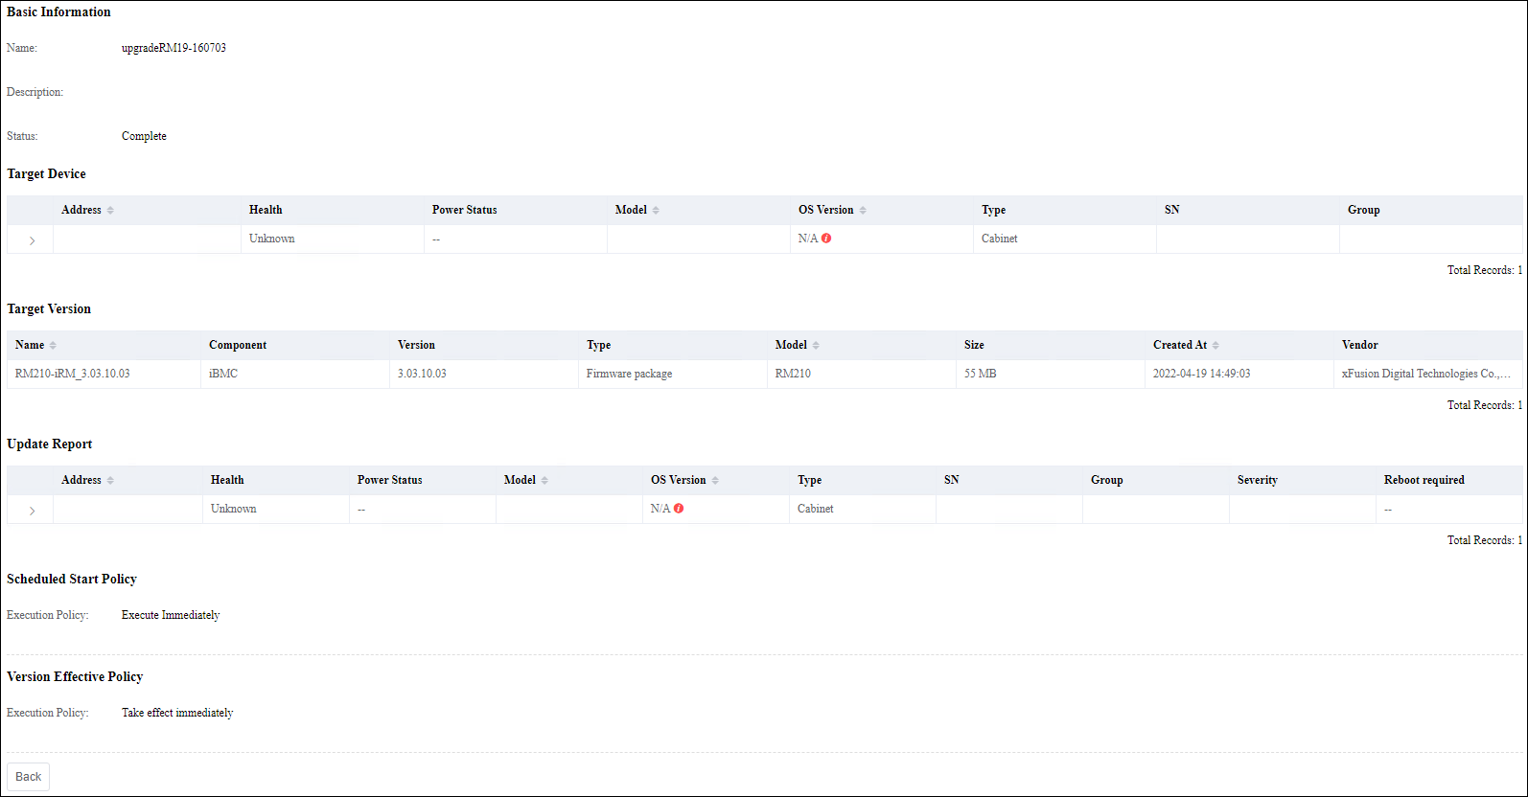

----End

### Checking Device Version and Status

Log in to the server.

Choose **Start** > **Configuration Manager Console** to log in to the SCCM.



If **Configuration Manager Console** cannot be found on the **Start** panel, return to the desktop, right-click **Start**, choose **Search** from the shortcut menu, and enter **Configuration Manager Console** in the search box to find **Configuration Manager Console**.

The SCCM main window is displayed, as shown in Figure 3-68.

SCCM main window



Choose **XFUSION > Firmware Update** > **Device Version Information**.

The **Device Version Information** page is displayed, as shown in Figure 3-69.

Device version information

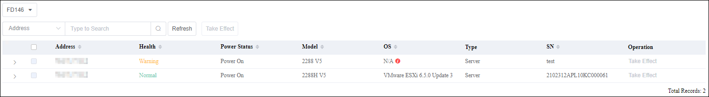

Select a FusionDirector system.

In the server list, click to view the device version information of the server, as shown in Figure 3-70.



Detailed device version information

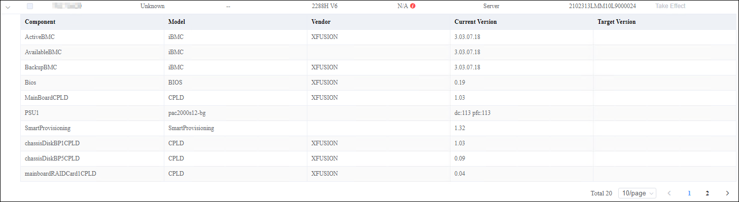

----End

## Managing Tasks

Manage FusionDirector tasks on the SCCM.

Procedure

Log in to the server.

Choose **Start** > **Configuration Manager Console** to log in to the SCCM.



If **Configuration Manager Console** cannot be found on the **Start** panel, return to the desktop, right-click **Start**, choose **Search** from the shortcut menu, and enter **Configuration Manager Console** in the search box to find **Configuration Manager Console**.

The SCCM main window is displayed, as shown in Figure 3-71.

SCCM main window



Choose **XFUSION** > **Task**.

The **Task** page is displayed. On the **Task** page, you can query and delete tasks, as shown in Figure 3-72.

Task page

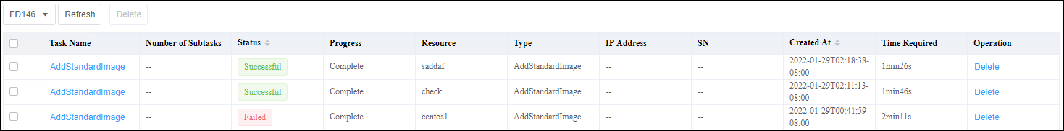

----End

## Viewing the SCCM Plug-in Version

Procedure

Log in to the server.

Choose **Start** > **Configuration Manager Console** to log in to the SCCM.



If **Configuration Manager Console** cannot be found on the **Start** panel, return to the desktop, right-click **Start**, choose **Search** from the shortcut menu, and enter **Configuration Manager Console** in the search box to find **Configuration Manager Console**.

The SCCM main window is displayed, as shown in Figure 3-73.

SCCM main window



Choose **XFUSION** > **About**.

The **About** window is displayed, as shown in Figure 3-74.

About



The value of **Version** is the SCCM plug-in version.

----End

# FAQs

4.1 Connection Test Failed When You Add FusionDirector Server

4.2 DLL File Is Missing When the SCCM Plug-in Is Used

## Connection Test Failed When You Add FusionDirector Server

Symptom

After a FusionDirector server is added, a failure message is displayed during the connection test.

Cause

* The network is abnormal.
* The user name or password is incorrect.
* The FusionDirector northbound interface user is locked.

Solution

* The network is abnormal.

Ensure that the network between the SCCM and FusionDirector is normal.

* The user name or password is incorrect.

You need to connect to FusionDirector as the **rootRedfish** user. Contact FusionDirector O&M personnel to obtain the correct **rootRedfish** user password.

* The FusionDirector northbound interface user is locked.

After being locked, the FusionDirector northbound interface user can be unlocked 5 minutes later.

## DLL File Is Missing When the SCCM Plug-in Is Used

Symptom

When the SCCM plug-in is used, a message is displayed indicating that the DLL file is missing, as shown in the following figure.

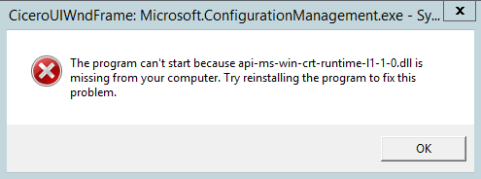

Solution

Install Visual C++ Redistributable for Visual Studio downloaded from

<https://www.microsoft.com/en-us/download/confirmation.aspx?id=48145>

* If the installation is successful, go to Step 2.
* If the installation fails, go to Step 3.

Access the SCCM plug-in and check whether the problem is resolved.

* If yes, no further action is required.
* If no, go to Step 3.

Download and install following patches for the Windows OS.

1. Install patch KB2919442 downloaded from

<https://www.microsoft.com/en-us/download/details.aspx?id=42153>

1. Install all patches of Windows Server 2012 R2 Update (KB2919355) downloaded from

<https://www.microsoft.com/en-us/download/details.aspx?id=42334>

Patches must be installed in the following sequence:

| Sequence | Patch | Size | Remarks |
| --- | --- | --- | --- |
| 1 | clearcompressionflag.exe | 38 KB | Run the patch as administrator. The installation is performed in the background without interfaces. |
| 2 | Windows8.1-KB2919355-x64.msu | 690.8 MB | Restart the system after the installation. The process takes some time. |
| 3 | Windows8.1-KB2932046-x64.msu | 48.0 MB | - |
| 4 | Windows8.1-KB2934018-x64.msu | 126.4 MB | - |
| 5 | Windows8.1-KB2937592-x64.msu | 303 KB | - |
| 6 | Windows8.1-KB2938439-x64.msu | 19.6 MB | - |
| 7 | Windows8.1-KB2959977-x64.msu | 2.8 MB | - |



After a patch is installed, restart the system as prompted for the patch to take effect. You can restart the system after all patches are installed.

1. Reinstall Visual C++ Redistributable for Visual Studio.

----End

1. Obtaining Technical Support

To obtain assistance, contact technical support as follows:

* Contact customer service center at [support@xfusion.com](mailto:support@xfusion.com).
* Contact technical support personnel.